Goal: I can complete and submit assignments on time Name:_________________________
Math Homework Week 10 Q3 (#1) Remember to do IXL Math a few times a week!
Monday:
: Show this number 3 different ways (ie. tally marks, coins, number bond, math
equation, etc)
25
Tuesday:
Fill in the missing numbers (use your number grid to find the number on top/below; left/right).

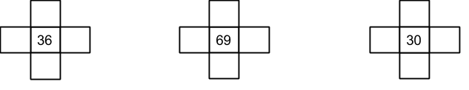

Wednesday:
Build a tally chart with the following information. The Leprechaun has 17 shamrocks, 10 pieces of gold, and 8 pieces of chocolate.
Write a question about your graph:_____________________________________________________________________________

Thursday:
Complete Tens and Ones sheet on the back.

Friday:
IXL Math

Ms.chris@academyoflit.org http://mschrisclassroom.weebly.com/

Goal: I can complete and submit assignments on time Name:_________________________
Math Homework Week 10 Q3 (#2) Remember to do IXL Math a few times a week!
Monday:
In the Clouds sheet (be sure to watch the signs). Please do A-C

Tuesday:
Solve and explain your thinking:

51-23

29+14

76-48

Wednesday:
In the Clouds sheet (D and E)

Thursday:
Draw and Multiply sheet
Friday:
IXL Math!

Ms.chris@academyoflit.org http://mschrisclassroom.weebly.com/

