Goal: I can complete and submit assignments on time Name:_________________________
Math Homework Week 9 Q3 (#1) Remember to do IXL Math a few times a week!
Monday:
S Show this number three different ways:
17
Tuesday:
Fill in the missing numbers (use your number grid to find the number on top/below; left/right).

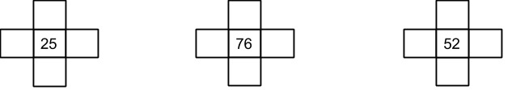

Wednesday:
Build a tally chart with the following information. Ms. Shar has 6 comic books, 12 picture books, and 8 chapter books.
Write a question about your graph:_____________________________________________________________________________

Thursday:
List 3 attributes of the shape below:

Friday:
IXL Math

Ms.chris@academyoflit.org http://mschrisclassroom.weebly.com/
Goal: I can complete and submit assignments on time Name:_________________________
Math Homework Week 9 Q3 (#2) Remember to do IXL Math a few times a week!
Monday:
Use pictures, numbers, and words to solve: Ms. Stephanie has 19 children in her math class. Ms. Chris has 20 in her math class. Ms. Miranda has 23 in her math class. How many children are in all three classes?

Tuesday:
Solve and explain your thinking:

40-12

89+17

99+14

Wednesday:
Ms. Connie would like to give each scholar 3 pieces of candy. If there are 19 students in our math class, how many pieces of candy will Ms. Connie need to buy? Use picture, numbers, and words to show your work.

Thursday:
Take 100 Game: See attached.
Friday:
IXL Math!

Ms.chris@academyoflit.org http://mschrisclassroom.weebly.com/

